Unit 1

Microprocessor

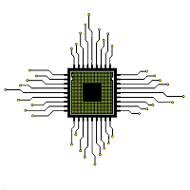

**What is a Microprocessor?**

Computer's Central Processing Unit (CPU) built on a single Integrated Circuit (IC) is called a microprocessor.

A digital computer with one microprocessor which acts as a CPU is called microcomputer.

It is a programmable, multipurpose, clock -driven, register-based electronic device that reads binary instructions from a storage device called memory, accepts binary data as input and processes data according to those instructions and provides results as output.

The microprocessor contains millions of tiny components like transistors, registers, and diodes that work together.

**Basic Terms used in Microprocessor**

**Instruction Set** - The group of commands that the microprocessor can understand is called Instruction set. It is an interface between hardware and software.

**Bus** - Set of conductors intended to transmit data, address or control information to different elements in a microprocessor. A microprocessor will have three types of buses, i.e., data bus, address bus, and control bus.

**IPC (Instructions Per Cycle)** - It is a measure of how many instructions a CPU is capable of executing in a single clock.

**Clock Speed** - It is the number of operations per second the processor can perform. It can be expressed in megahertz (MHz) or gigahertz (GHz). It is also called the Clock Rate. Bandwidth - The number of bits processed in a single instruction is called Bandwidth.

**Word Length** - The number of bits the processor can process at a time is called the word length of the processor. 8-bit Microprocessor may process 8 -bit data at a time. The range of word length is from 4 bits to 64 bits depending upon the type of the microcomputer.

**Data Types** - The microprocessor supports multiple data type formats like binary, ASCII, signed and unsigned numbers.

**Working of Microprocessor**

The microprocessor follows a sequence to execute the instruction: Fetch, Decode, and then Execute.

Initially, the instructions are stored in the storage memory of the computer in sequential order. The microprocessor fetches those instructions from the stored area (memory), then decodes it and executes those instructions till STOP instruction is met. Then, it sends the result in binary form to the output port. Between these processes, the register stores the temporary data and ALU (Arithmetic and Logic Unit) performs the computing functions**.**

**Microprocessor Architecture**

The microprocessor is the CPU (Central Processing Unit) of a computer. It is the heart of the computer. Here, we will describe Intel 8085 as it is one of the most popular 8-bit microprocessor.

Intel 8085 is an 8-bit, NMOS microprocessor designed by Intel in 1977.

**It has following configuration:**

1. It is a 40 pin I.C. package fabricated on a single LSI chip.
2. The Intel 8085 uses a single +5Vd.c. supply for its operation.
3. Intel 8085s clock speed is about 3 MHz; the clock cycle is of 320ns.
4. 8 bit data bus.
5. Address bus is of 16-bit, which can address up to 64KB
6. 16-bit stack pointer
7. 16 bit PC (Program Counter)
8. Six 8-bit registers are arranged in pairs :BC, DE, HL

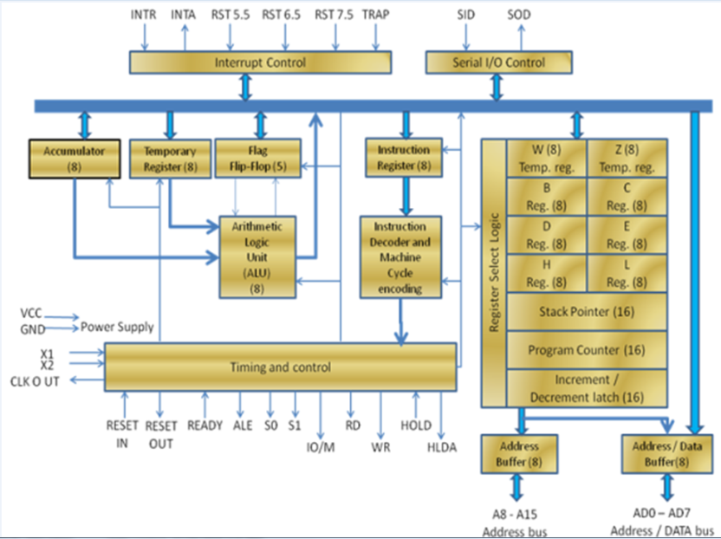

**ALU**

The Arithmetic and Logic Unit, ALU performs the arithmetic and logical operations:

Addition

Subtraction

Logical AND

Logical OR

Logical EXCLUSIVE OR

Complement (Logical NOT)

Increment (add 1)

Decrement (subtract 1)

Left shift, Rotate left, Rotate right

Clear, etc.

**Timing and Control Unit**

The timing and control unit is the section of the CPU.

It is used to generate timing and control signals which are necessary for the execution of instructions.

It is used to control data flow between CPU and peripherals (including memory).

It is used to provide status, control and timing signals which are required for the operation of memory and I/O devices.

It is used to control the entire operations of the microprocessor and peripherals connected to it.

Thus we can see that the control unit of the CPU acts as the brain of the computer system.

**Registers**

Registers are used for temporary storage and manipulation of data and instructions by the microprocessor. Data remain in the registers till they are sent to the I/O devices or memory. Intel 8085 microprocessor has the following registers:

* One 8-bit Accumulator (ACC) i.e. register A
* Six general purpose registers of 8-bit, these are B,C, D, E, H and L
* One 16-bit stack pointer, SP
* One 16-bit Program Counter, PC
* Instruction register
* Temporary register

In addition to the above mentioned registers the 8085 microprocessor contains a set of five flip-flops which serve as flags (or status flags).

A flag is a flip-flop which indicates some conditions which arises after the execution of an arithmetic or logical instruction.

**Accumulator (ACC):** The accumulator is an 8-bit register associated with the ALU. The register 'A' is an accumulator in the 8085. It is used to hold one of the operands of an arithmetic and logical operation.  
The final result of an arithmetic or logical operation is also placed in the accumulator.

**General-Purpose Registers:** The 8085 microprocessor contains six 8-bit general purpose registers. They are: B, D, C, E, H and L register.  
To hold data of 16-bit a combination of two 8-bit registers can be employed.  
The combination of two 8-bit registers is called **register pair**. The valid register pairs in the 8085 are: D-E, B-C and H-L. The H-L pair is used to act as a memory pointer.

**Program Counter (PC):** It is a 16-bit special purpose register. It is used to hold the address of memory of the next instruction to be executed. It keeps the track of the instruction in a program while they are being executed.  
The microprocessor increments the content of the next program counter during the execution of an instruction so that at the end of the execution of an instruction it points to the next instructions address in the program.

**Stack Pointer (SP):** It is a 16-bit special function register used as memory pointer. A stack is nothing but a portion of RAM. In the stack, the contents of only those registers are saved, which are needed in the later part of the program.  
The stack pointer (SP) controls the addressing of the stack. The Stack Pointer contains the address of the top element of data stored in the stack.

**Instruction Register:** The instruction register holds the opcode (operation code or instruction code) of the instruction which is being decoded and executed.

**Temporary Register:** It is an 8-bit register associated with the ALU. It holds data during an arithmetic/logical operation. It is used by the microprocessor. It is not accessible to programmer.

**Flags:** The Intel 8085 microprocessor contains five flip-flops to serve as a status flags. The flip-flops are reset or set according to the conditions which arise during an arithmetic or logical operation.

**The five status flags of Intel 8085 are:**

1. Carry Flag (CS)

2. Parity Flag (P)

3. Auxiliary Carry Flag (AC)

4. Zero Flag(Z)

5. Sign Flag(S)

If a flip-flop for a particular flag is set, then it indicates 1. When it is reset, it indicates 0.